Lab02

Question3

i.The status code is 200， and the phrase is “OK”



Ii.

It contains both the last modified date(Date: Tue, 23 Sep 2003 05:29:00 GMT\r\n) and the date header(Date: Tue, 23 Sep 2003 05:29:50 GMT\r\n). The date header stores the date that the request is made rather than the time of last modification.

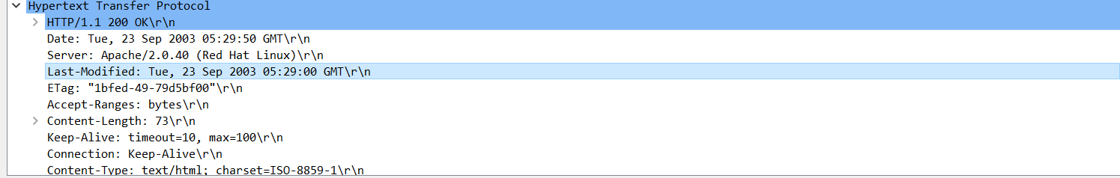

Iii.

If we check the request made by the browser to the server, we will find in the connection field that the browser is requesting “keep-alive” which means the connection will not be dropped after the request is made and respond until the browser or the server drops the connection.Therefore the connection is persistent.

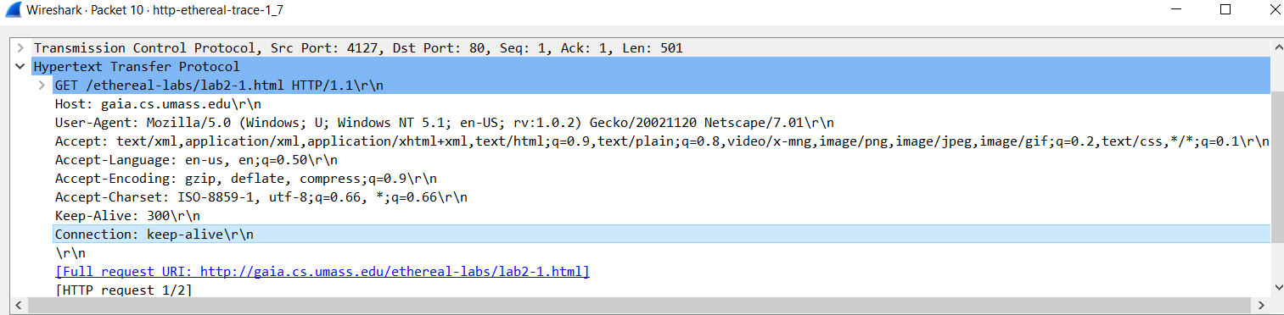

IV.

In this case, we only care about the size of HTTP content because the question is asking about the size of content received by the browser which is located at application level. This means it will only accept the protocols in application level which is HTTP in this case. Therefore the size of the content is 73 bytes.

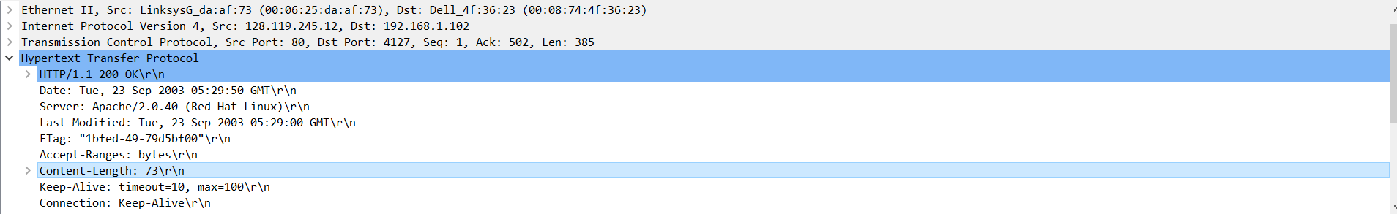

V.

The contained data is 3 lines of HTML code

1.\n

2.Congratulations. You've downloaded the file lab2-1.html!\n

3.\n

Question4.

1.No, there is no field called “IF-MODIFIED-SINCE”

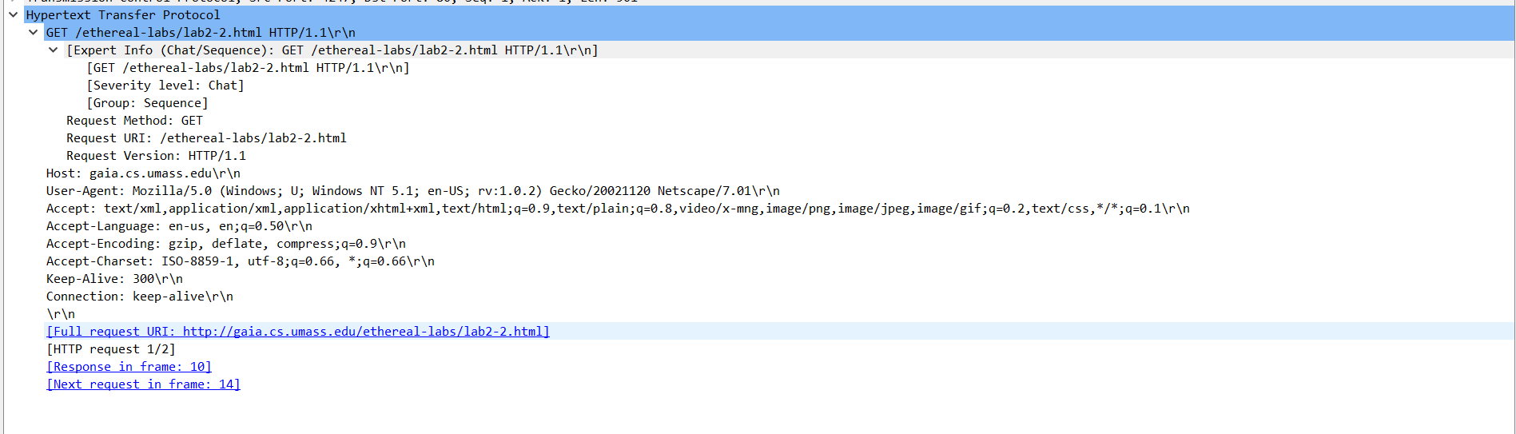

ii.Yes it does. The last modified field in the response suggests that it was last modified on Tue, 23 Sep 2003 05:35:00 GMT\r\n.

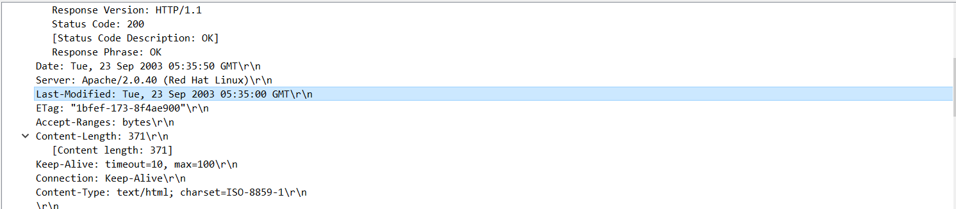

iii.Yes I can see both of them.

For IF-MODIFIED-SINCE:Tue, 23 Sep 2003 05:35:00 GMT\r\n, it contains the last modified time.

For IF-None-Match: it contains

"1bfef-173-8f4ae900"\r\n which is an ETAG.

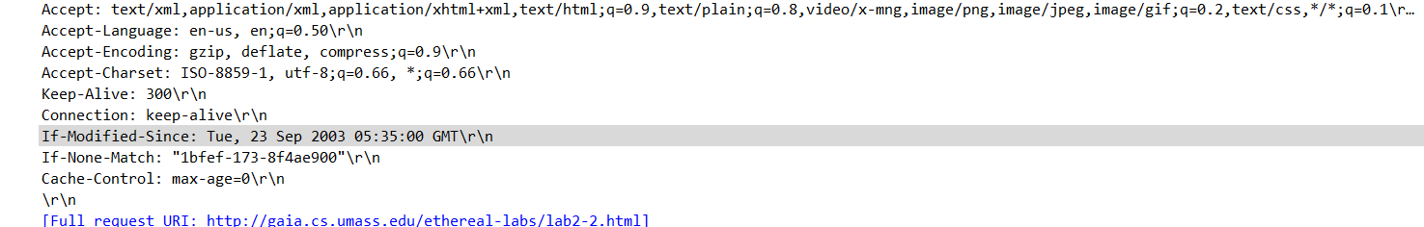

iv.The status code is 304, and the phrase is Not Modified, the server did not explicitly return any contents back to the browser, this is due to the “If -Modified-Since” field is used in the request which will help determine whether or not the resource has changed(updated) since the last time it was accessed. Since the file has not updated, the GET response returns with no continent body but just the message of the file has not been updated.

v.The value of Etag in the second response message is ETag: "1bfef-173-8f4ae900"\r\n. The Etage is used by “If-None-Match”for checking the version of the file, if the server has the Etag matching with the current one, it means the file is not updated, therefore the server will not return any body content.

No, the ETAG has not changed since the first

Response( "1bfef-173-8f4ae900"\r\n).

Response 2

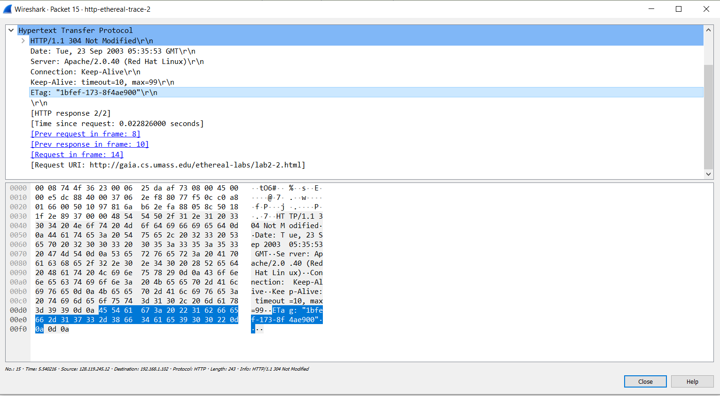

Response 1

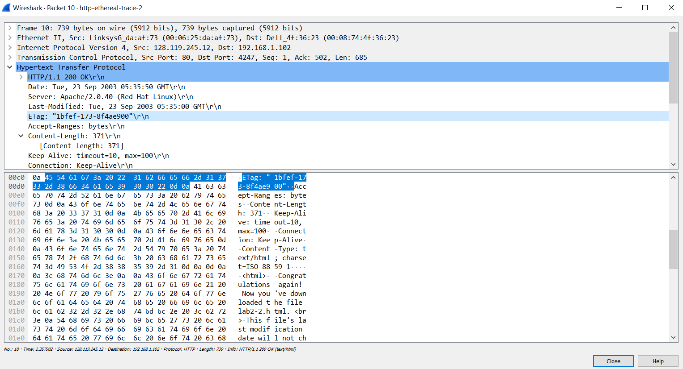

Question 5

Please see ClientPing.py, the source code is also provided here in case of ClientPing.py is not successfully uploaded.

#Note please use python 3.6.9 or python 3.7 to run this program

import sys

from socket import *

from datetime import datetime

from timeit import default_timer as timer

#get host and name

host = sys.argv[1]

port = int(sys.argv[2])

#create socket for client, use UDP packet

clientSocket = socket(AF_INET, SOCK_DGRAM)

# send 15 requests in total

counter = 0

# initial seq num

seq = 3331

clientSocket.settimeout(0.6)

# sending reuest and recive them

while counter < 15:

# parepare the payload

payload = 'Ping' + ' ' + str(seq) + ' ' + str(datetime.now())

# send the request to the server

start = timer()

fullstart = start

clientSocket.sendto(payload.encode('utf-8'),(host, port))

status = 0

message_from_server = None

try:

message_from_server,serveraddress = clientSocket.recvfrom(port)

except timeout:

print("Packet {} is lost !!!!!\r\n".format(seq))

pass

end = timer()

if message_from_server != None:

message = 'Ping ' + str(seq) + ' ' + str((1000 * (end - fullstart))) + 'ms' + '\r\n'

print(message)

counter += 1

seq += 1

# close the socket

clientSocket.close()